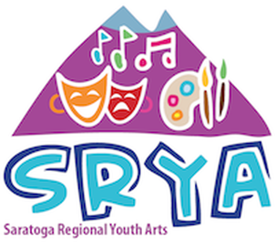
2018 Summer Camp Registration Form

PLEASE READ THIS APPLICATION CAREFULLY
Please complete the entire application and mail it along with your enrollment fee to:
SRYA Summer Camps, PO Box 2452, Gansevoort, NY 12831

Students Name: Nickname:

Date of Birth: Age: Gender:

Mailing Address:
Street City State Zip

Tee-Shirt Size: Youth: Small Medium Large X-Large
PLEASE CIRCLE ONE Adult: Small Medium Large X-Large

Name of Parent(s)/Guardian(s)

Mailing Address (if different)

Day Phone: ( ) Evening Phone: ( )

Cell Phone: ( ) Email:

Emergency Information

Physician: Phone:

Health Insurance: Y N Company Name: ID#:

The above entrant is in appropriate health and physical condition to participate in an arts program and will exercise good judgement and restraint so far as his/her health and well-being and the well-being of others are concerned. I/we expressly authorize any and all emergency medical treatment which may be necessary in the event of an accident in the case I/we cannot be reached in a timely manner.

Parent/Guardian signature: Date:

Please complete the application and mail it along with your enrollment fee to:
SRYA Summer Camps, PO Box 2452, Gansevoort, NY 12831

2

PAYMENT FORM

I would like to enroll my child/children in the following Camp(s)

Rent, High School - July 23 to August 4 $450.

Suessical Junior - July 23 to August 3 $450.

Lion King Junior - Aug 6 to August 11 $250.

Payment method:

Check enclosed (Full Payment)

Check enclosed (1/2 Payment – balance due by June 1, 2018)

Credit Card Payment (Full Payment)

Credit Card Payment (1/2 Payment – balanced charged on June 1, 2018)

Visa/MC Card #: Exp. Date: CVV#:

Signature: Date:

Please mail all forms and payment to:
SRYA Camps, PO Box 2452, Gansevoort, NY 12831

Date rec’d Deposit rec’d Full pmt rec’d

